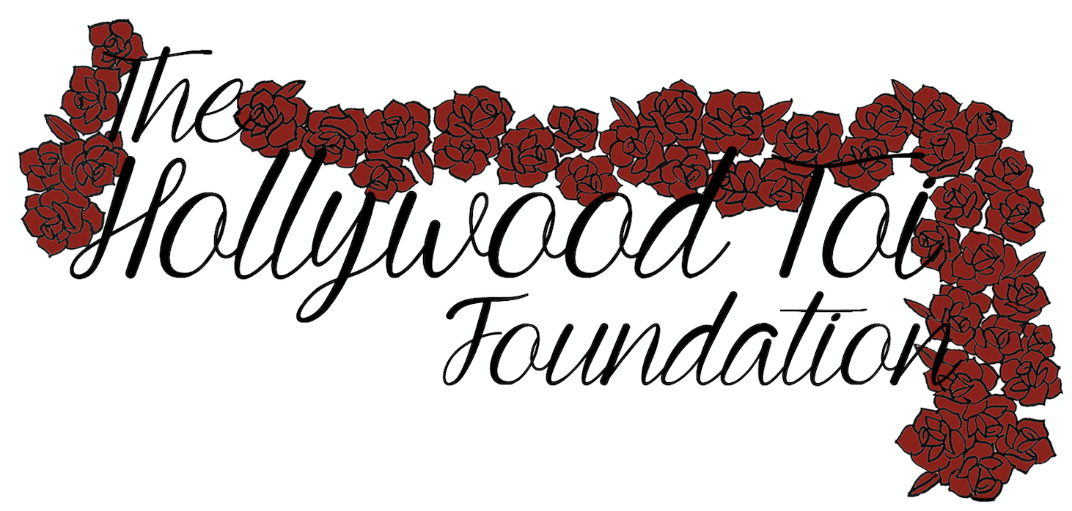

2023 Arabian Youth Nationals
Sponsorship Application

Once completed, please save this document as “Last Name_First Name” and submit it via email to hollywoodtoifoundation@gmail.com by April 20th.
Please submit it as either a Word or PDF file; we do not accept Google Doc links.
Thank you! You will be emailed a confirmation once we receive your application.

Basic Information
First Name:
Last Name:
City/State:
Age:
Phone Number:
Email:

Showing Information
Barn Affiliation:
Trainer Name:
Trainer Email:
Age Division:
Discipline(s) Competing In:
Have you attended Youth Nationals before?:
Which year(s), if any?:

References

Reference #1
Name:
Email:
Relationship:

Reference #2
Name:
Email:
Relationship:

Essay Questions
Please answer the following questions. You are welcome to respond with individual answers to each question, or with an essay that combines both answers into one. Only the first two questions below are required, but if there’s anything else you’d like us to know that you haven’t gotten a chance to talk about yet, you are more than welcome to include that as well. Thank you for applying!

- Why should you be considered for this sponsorship?
- What does showing the Arabian horse mean to you?
- Optional: Is there anything else you’d like us to know that hasn’t yet been reflected in your application?

